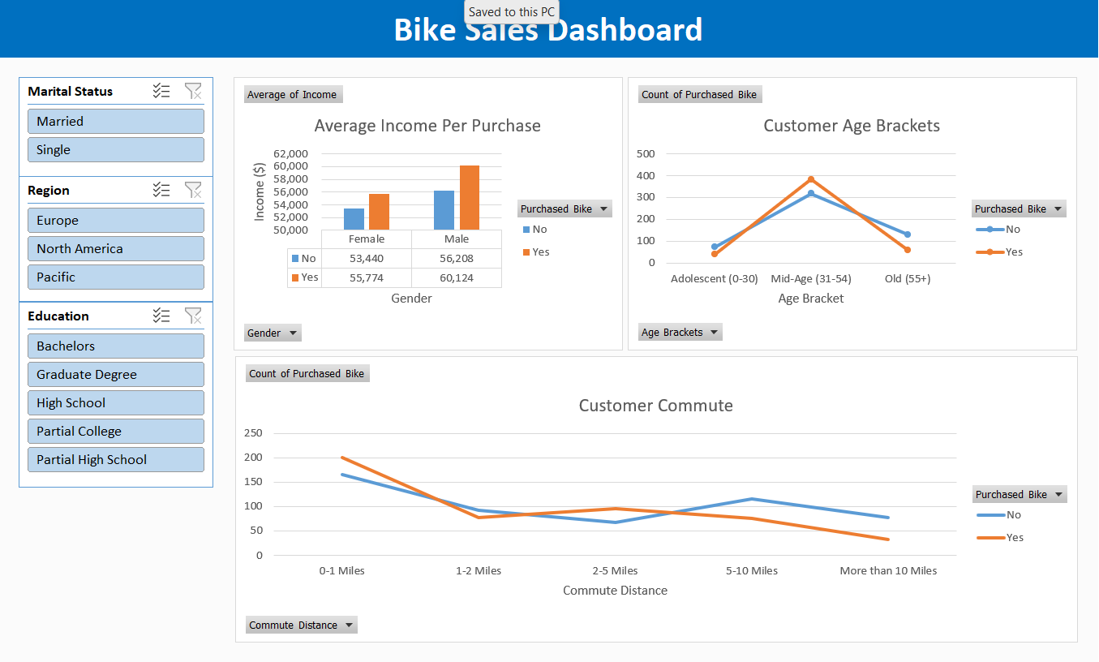**Microsoft Excel Project** Malvi Bid